

UNIVERSITY OF BUEA
FACULTY OF ENGINEERING AND TECHNOLOGY
DEPARTMENT OF COMPUTER ENGINEERING

CEF 440: INTERNET PROGRAMMING AND MOBILE PROGRAMMING

TASK 4 REPORT: SYSTEM MODELING AND DESIGN

Course instructor : Dr Nkemeni Valery

AFUH CHIKE CHEWAKONDI | FE23A005
PIGHIEBWOH NOKA GILDAS | FE23A135
TAKANG BRANDON EYONG | FE23A149
TAKU YVETTE WUTOH | FE23A152
TAMANTENG ABERLINE NGUEMUTANG | FE23A154

Table of Contents
TASK 4 REPORT: SYSTEM MODELING AND DESIGN 1
I. Introduction 3
II. Context Diagram 3
III. Data Flow Diagrams 6
5. Why the DFD Hierarchy Matters 10
IV. Use Case Diagram 11
V. Sequence Diagrams 14
3. Adaptive Streaming Flow 15
VI. Class Diagram 21
2. Unified Modeling Language (UML) Structural Notation 22
3. Domain Specialization and Class Responsibilities 22
3.1 Identity Management Domain 23
3.2 Asynchronous Content and Adaptive Streaming Domain 23
3.3 Evaluation and Communication Domain 23
4. Structural Relationships and Design Rationale 24
4.1 Generalization (The Common Identity Rule) 24
4.2 Aggregation over Composition (The Content Lifecycle Rule) 24
4.3 Association and Multiplicity Matrix 24
4.4 Separation of Quiz/Reminder from the Student Class 25
VII. Deployment Diagram 26
VIII. Conclusion and References 31
1. Context Diagram (DFD Level 0) 32
2. Data Flow Diagrams (Levels 1–3) 32
3. Use Case Diagram 32
4. Sequence Diagrams 32
5. Class Diagram 33
6. Deployment Diagram 33
Final Reflection 33
References 34

I. Introduction
System modelling is the art of turning abstract requirements into visual blueprints that guide implementation. For the Adaptive E-Learning Platform, modelling ensures that learners in low-resource settings can access content seamlessly, whether online or offline, and instructors can deliver lectures with confidence.
This report uses six diagrams — Context, Data Flow (Levels 0–3), Use Case, Sequence, Class, and Deployment — to capture every dimension of the system. Each diagram is explained in detail, with placeholders for insertion.

II. Context Diagram
The Context Diagram (DFD Level 0) is the highest-level representation of the Adaptive E-Learning Platform. It shows the system as a single process surrounded by external entities, clarifying boundaries, responsibilities, and flows of information. This diagram is the foundation of all deeper models, because it defines who interacts with the system and what data moves in and out.
  - 1. Purpose of the Context Diagram
The purpose of the Context Diagram is to define the system boundary. It separates what is inside the Adaptive E-Learning Platform (authentication, content delivery, adaptive streaming, quizzes, notifications, QoE monitoring) from what lies outside (students, instructors, administrators, network/CDN, authentication services). By doing so, it prevents scope creep and ensures that stakeholders understand exactly what the system does and what it does not do.
It is like a map of a city showing only the highways — you see where traffic enters and exits, but not the internal streets. This clarity is essential before diving into detailed flows.
  - 2. External Entities
The Context Diagram identifies five external actors:
- Students: They are the primary learners. They send login credentials, request course materials, attempt quizzes, and receive results, feedback, and notifications. Their arrows into the system represent requests, while arrows out represent responses.
- Instructors: They are the content creators. They upload lectures, notes, and quizzes, and receive analytics reports. Their arrows represent uploads and management requests flowing in, and dashboards and feedback flowing out.
- Administrators: They are the system managers. They manage accounts, enforce policies, and oversee compliance. Their arrows represent account management requests and system updates.
- Network Environment/CDN: This external system supplies bandwidth and latency metrics, and streams video content. Its arrows represent network metrics flowing in and video streams flowing out.
- Authentication Services: These validate tokens and credentials, ensuring secure access. Their arrows represent credentials flowing in and validation results flowing out.
Each actor is outside the system boundary but interacts with the platform through labeled flows.
  - 3. Data Flows
The arrows in the Context Diagram represent information exchanges:
- Credentials Flow: Students → System → Auth Services → Validation → Students.
- Content Request Flow: Students → System → Instructors → Course Materials → Students.
- Video Stream Flow: System ↔ Network/CDN → Adaptive Delivery → Students.
- Analytics Flow: System → Instructors/Administrators → Reports, dashboards.
- Feedback Flow: Students → System → QoE Logs → Recommendation Engine → Students.
Each flow is labeled to avoid ambiguity, ensuring that stakeholders know exactly what data is moving.
  - 4. System Boundary
Inside the boundary is the Adaptive E-Learning Platform. It encapsulates all internal processes: authentication, content delivery, adaptive streaming, quiz management, notifications, and QoE monitoring. Outside the boundary are the actors and external services. This separation ensures clarity: developers know what to build, and stakeholders know what to expect.
  - 5. Engineering Perspective
Imagine the Context Diagram as a hub at the center of a busy intersection.
- Roads leading in are credentials, content requests, bandwidth metrics.
- Roads leading out are videos, quizzes, notifications, analytics reports.
- The hub (system) manages traffic so that no road is congested, and every traveler (student, instructor, admin) reaches their destination smoothly.
This analogy makes the diagram intuitive even for non-technical readers.
  - 6. Why It Matters
- Clarity: Prevents scope creep by defining what’s inside vs. outside.
- Communication: Non-technical stakeholders can understand system interactions.
- Foundation: Guides the creation of Level 1 and Level 2 DFDs.
- Validation: Ensures every requirement (offline access, adaptive streaming, authentication, quizzes, notifications) is represented.
Without the Context Diagram, deeper models would lack orientation.
The Context Diagram is the entry point into system modelling. It shows that the Adaptive E-Learning Platform is not isolated — it constantly exchanges information with students, instructors, administrators, the network environment, and authentication services. By clearly defining these boundaries and flows, the diagram ensures that when we move into detailed modelling (DFD Levels 1–3, Use Case, Sequence, Class, Deployment), we never lose sight of the bigger picture.

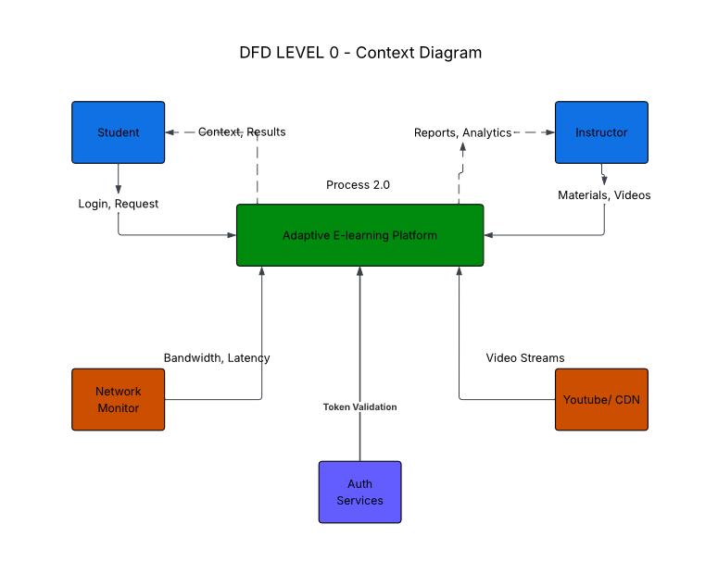

III. Data Flow Diagrams
The Data Flow Diagram (DFD) is the backbone of system modelling. It shows how information moves through the Adaptive E-Learning Platform, from external actors to internal processes and data stores. Unlike the Use Case Diagram, which focuses on what users do, the DFD focuses on how data flows and where it is transformed. To make this engaging, we will walk through the hierarchy step by step — from Level 0 (Context) down to Level 2 (Process Decomposition) — explaining every point in detail.
- Level 0 — Context Diagram
At this level, the entire Adaptive E-Learning Platform is represented as a single process box. Around it are the external entities that interact with the system.
- Students: They provide login credentials, request course materials, attempt quizzes, and receive results. Their arrows into the system represent requests (login, content, quizzes), while arrows out represent responses (results, feedback, notifications).
- Instructors: They upload course materials and quizzes, and receive analytics reports. Their arrows into the system represent uploads and management requests, while arrows out represent dashboards and feedback.
- Administrators: They manage accounts and system policies. Their arrows represent account management requests and system updates.
- Network Environment/CDN: This external system provides bandwidth and latency data, and streams video content. Its arrows represent network metrics flowing in and video streams flowing out.
- Authentication Services: These validate tokens and credentials. Their arrows represent credentials flowing in and validation results flowing out.
The Context Diagram is like a map of a city showing only the highways — you see where traffic enters and exits, but not the internal streets. It defines the boundary of the system and clarifies who interacts with it.


- Level 1 — Main System Processes
Here, the single process is expanded into six major processes, each representing a core function of the platform.
- 1.0 Authentication: This process validates credentials against the User Database and issues JWT tokens with roles. It ensures that only authorized actors gain access.
- 2.0 Course Content Management: Instructors upload lectures, notes, and quizzes, which are stored in the Course Database. Students request these materials, and the system delivers them.
- 3.0 Network Quality Monitoring: This process continuously collects bandwidth and latency data from the network environment. It logs throughput and passes metrics to the Adaptive Delivery Engine.
- 4.0 Adaptive Delivery Engine: The heart of the system. It decides whether to deliver HD video, SD video, audio-only, or offline cached content based on QoS scores and device profiles.
- 5.0 Video Streaming: This process handles ABR/HLS streaming, integrates with the CDN, and ensures smooth playback. It delivers .m3u8 and .ts segments to students.
- 6.0 QoE Assessment & 7.0 Recommendation Engine: These processes analyze QoE feedback, update ML models, and generate personalized recommendations for students.
Data Stores at Level 1:
- D1 User Database: Stores credentials, roles, and quiz results.
- D2 Course Database: Stores lectures, notes, and quizzes.
- D3 Network Logs: Stores bandwidth and latency metrics.
- D4 QoE Metrics Store: Stores satisfaction ratings and QoE scores.
- D5 Recommendation Model Store: Stores ML weights and cached models.
- D6 Video/Media Cache: Stores offline content for students.
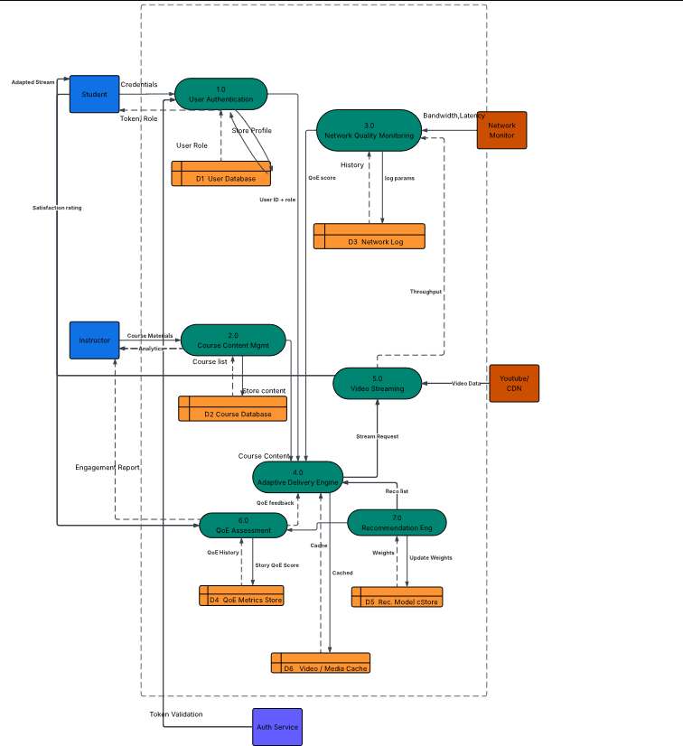
- Level 2 — Expanded Processes
At this level, each major process is shown interacting with specific data stores and external entities.
- Authentication (1.0): Credentials flow from students to the system, are validated against the User Database, and return tokens/roles.
- Course Content Management (2.0): Instructors upload content into the Course Database. Students request content, which flows back to them via the system.
- Network Quality Monitoring (3.0): Bandwidth and latency data flow into the Network Logs. These logs are then accessed by the Adaptive Delivery Engine.
- Video Streaming (5.0): Stream requests flow from students to the Course Database and CDN, which return video/audio streams.
- QoE Assessment (6.0): Feedback flows from students into the QoE Metrics Store. The Recommendation Engine accesses this store to update models and generate personalized suggestions.
This level is like zooming into the city map to see the main streets and intersections. You now see how data moves between processes and storage.

- Level 3 — Adaptive Delivery Decomposition
Process 4.0 Adaptive Delivery Engine is complex, so it is decomposed into five sub-processes:
- 4.1 Quality Banding: Maps measured throughput into quality tiers (HD, SD, audio).
- 4.2 QoS Classifier: Combines device profile and QoS score to select the best format.
- 4.3 Bitrate Negotiator: Chooses codec, bitrate, and buffer strategy. It decides chunk size and prefetch policy.
- 4.4 Offline Content Manager: Triggers offline caching when bandwidth fails. It manages the offline_cache.db and ensures students can continue learning without internet.
- 4.5 Buffering Optimizer: Prefetches video segments, smooths playback, and logs delivery events.
Control Flow:
- The Network Monitor polls bandwidth every 2 seconds.
- If bandwidth <128 kbps for 5 seconds, the system switches to audio-only mode.
- If bandwidth >500 kbps, the system resumes 480p video.
This level is like zooming into the neighborhood map — you see the side streets, traffic lights, and how cars (data) are directed at each junction.
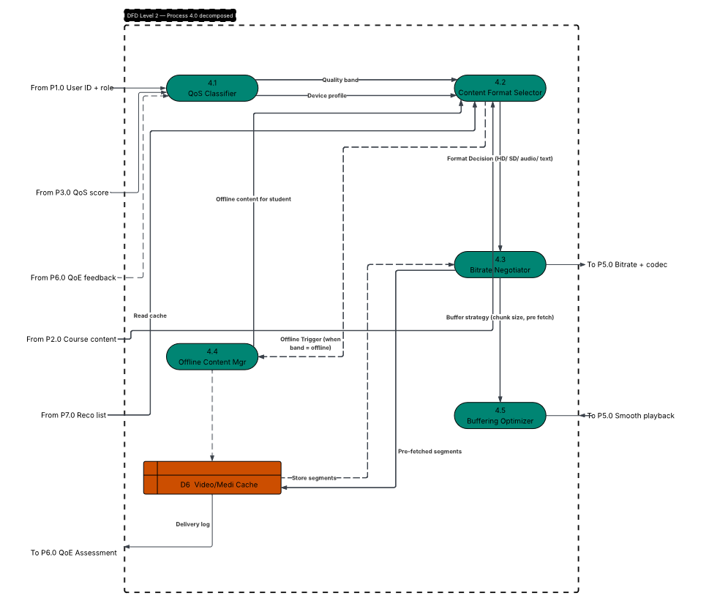

Why the DFD Hierarchy Matters
- Level 0: Defines boundaries and external actors.
- Level 1: Shows main processes and data stores.
- Level 2: Expands flows for clarity.
- Level 3: Reveals internal decision logic.
This layered approach prevents clutter, ensures readability, and allows stakeholders to zoom in or out depending on their role (developer, manager, student).
The DFD hierarchy — from Context (Level 0) to Adaptive Delivery decomposition (Level 3) — provides a complete, layered model of our Adaptive E-Learning Platform. It ensures that authentication, content delivery, adaptive streaming, quizzes, notifications, and QoE monitoring are not just listed as requirements but are modeled as flows of information, ready for implementation.

IV. Use Case Diagram
The Use Case Diagram is the narrative map of how different actors interact with the Adaptive E-Learning Platform. Unlike the DFDs, which focus on data movement, the Use Case Diagram emphasizes functional requirements from the user’s perspective. It is essentially a storyboard of actions, showing what each actor can do, how the system responds, and how these actions interrelate.
  - 1. The Student Actor
The Student is the central figure in the system. Their use cases represent the learning journey from enrollment to feedback.
- Enroll & Unenroll: Students begin by enrolling in courses. Enrollment triggers authentication, role assignment, and course linkage. Unenrollment removes the student’s association with a course but does not delete the course itself, preserving academic integrity.
- Signup/Login (Include): Every student interaction begins with secure login. This is an include relationship because authentication is mandatory before accessing any other function.
- Access Course Material & Download: Students can view lectures, notes, and quizzes online or download them for offline use. The download function ties directly to the offline cache manager in the deployment tier.
- Track Progress & Check History: Students monitor their learning journey through dashboards and historical logs. This ensures transparency and motivates engagement.
- Take Quizzes & Check Scores: Students attempt quizzes, receive instant feedback, and check scores. This use case connects to the Quiz Management process in the DFD.
- Submit Feedback: Students provide QoE feedback, which feeds into the recommendation engine. This closes the loop between user experience and system improvement.
The student’s use cases embody the learner-centered philosophy of the platform, ensuring that every action contributes to personalized, adaptive learning.
  - 2. The Instructor Actor
The Instructor is the content creator and evaluator. Their use cases define how knowledge enters the system and how student engagement is monitored.
- Signup/Login (Include): Like students, instructors must authenticate before performing any action.
- Upload Course Material: Instructors upload lectures, notes, and quizzes. This ties directly to the Course Content Management process in the DFD and the FFmpeg transcoder in the deployment diagram.
- Manage Classes: Instructors organize courses, assign students, and schedule lectures. This ensures structured delivery.
- Assign Quizzes: Instructors create and publish quizzes, which are cached locally on student devices for offline attempts.
- Monitor Student Dashboard: Instructors view analytics dashboards showing student progress, completion rates, and engagement metrics. This use case connects to the QoE analytics engine and recommendation system.
The instructor’s use cases highlight the pedagogical backbone of the system, ensuring that content is not only delivered but also evaluated and improved.
  - 3. The Administrator Actor
The Administrator ensures governance, compliance, and system integrity.
- Signup/Login (Include): Administrators authenticate before managing accounts.
- Manage Accounts: They add, remove, or update student and instructor profiles. This use case connects to the User Database in the DFD and ensures role-based access control.
Administrators embody the management perspective, ensuring that the system remains secure, compliant, and scalable.
  - 4. The Developer Actor
The Developer represents the technical maintenance side of the system.
- Test Software (Extend): Developers test modules, simulate network conditions, and validate adaptive streaming. This is modeled as an extend relationship because testing is not part of normal user interaction but extends system functionality.
- Update Software: Developers push updates, fix bugs, and enhance features. This ties directly to the deployment diagram, where Docker containers and cloud services allow rolling updates.
The developer’s use cases ensure continuous improvement, keeping the system resilient and future-proof.
  - 5. Relationships in the Diagram
- Include Relationships: Signup/Login is included in Student, Instructor, and Administrator use cases because authentication is mandatory.
- Extend Relationships: Developer’s Test Software extends the system’s normal operation, representing optional but critical maintenance.
- Cross-Actor Relationships: Students and Instructors share an include relationship because their roles overlap in authentication and course interaction.
These relationships ensure that the diagram is not just a list of actions but a network of dependencies and extensions, reflecting real-world system behavior.
  - 6. Why the Use Case Diagram Matters
- It humanizes system design by showing how real people interact with the platform.
- It ensures that functional requirements are captured before technical implementation.
- It connects directly to other diagrams:
  - Student’s “Take Quiz” → Quiz Management in DFD.
  - Instructor’s “Upload Content” → Course Content Management in DFD.
  - Administrator’s “Manage Accounts” → User Database in DFD.
  - Developer’s “Update Software” → Deployment Diagram (Docker containers).

The Use Case Diagram is the storyboard of the Adaptive E-Learning Platform. It shows how students learn, instructors teach, administrators manage, and developers maintain. By modeling these interactions with include and extend relationships, the diagram ensures that the system is user-centered, secure, and continuously evolving.
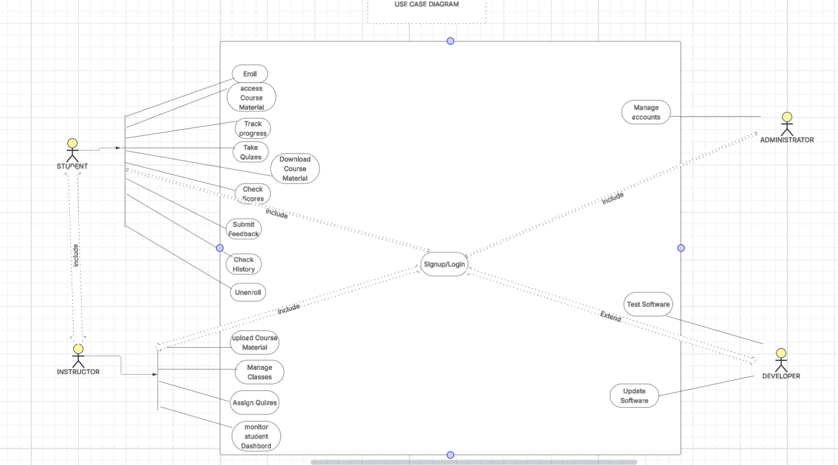

V. Sequence Diagrams
The Sequence Diagrams capture the dynamic heartbeat of the Adaptive E-Learning Platform. Unlike the DFDs, which show what flows where, sequence diagrams show when and in what order things happen. They are essentially scripts for the play of system interactions, detailing lifelines, messages, and timing conditions. From our documents, we have several key flows.
  - 1. User Authentication Flow (Login)
This scenario begins when a student attempts to log in.
- The Student App sends credentials to the Authentication Service.
- The Auth Service queries the User Database to validate the credentials.
- Once validated, the Auth Service issues a JWT token and assigns a role (student, instructor, or admin).
- The token is returned to the Student App, enabling secure access to the platform.
This flow ensures that every interaction is secure, role-based, and authenticated.
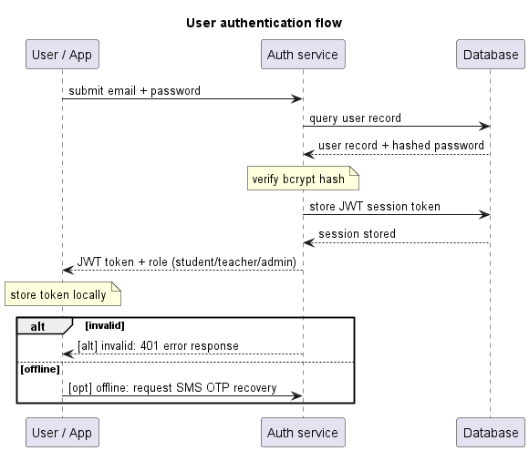
  - 2. Offline Content Download Flow
This scenario addresses the challenge of poor connectivity.
- The Network Monitor checks bandwidth and measures connection speed.
- Based on results, the Student App selects a quality tier (standard 100–300 MB).
- If the student chooses offline mode, the Lecture is downloaded into local storage.
- File chunks are streamed back to the app, enabling offline playback.
This flow ensures that learning continues even when the internet fails.
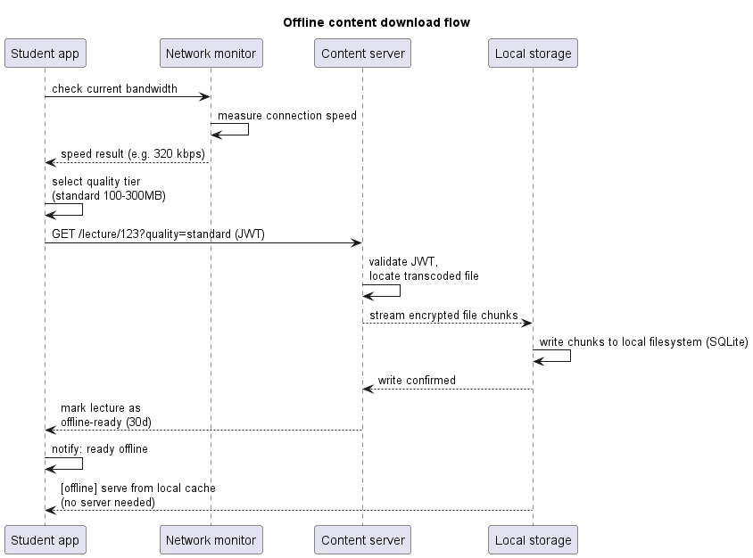

3. Adaptive Streaming Flow
This is the most critical dynamic flow, ensuring smooth playback under varying bandwidth conditions.
- The Stream Server serves video at 500 kbps with 480p resolution.
- The Network Monitor polls bandwidth every 2 seconds.
- If bandwidth stays below 128 kbps for 5 seconds, the Player automatically switches to audio-only mode.
- A notification pops up, and an “audio-only mode” banner is displayed.
- If bandwidth is restored above 500 kbps, the banner is dismissed, and 480p video resumes.
This flow embodies the adaptive intelligence of the platform.
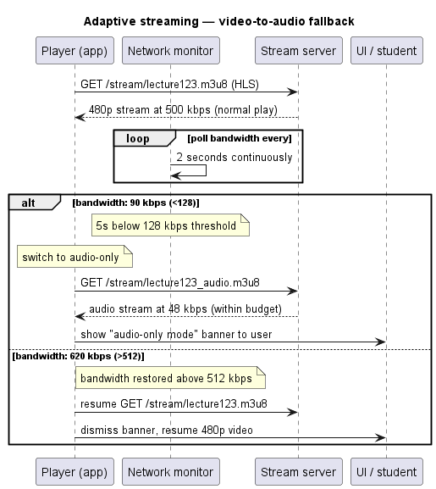
  - 4. Quizzing Flow (Offline Attempt and Sync)
This scenario ensures that students can attempt quizzes even without internet.
- The Student App requests cached quiz questions from the Local Database (SQLite).
- Questions are served as JSON from local cache.
- The student’s progress is auto-saved every 30 seconds.
- Answers are timestamped and stored locally.
- When connectivity is restored, the Background Sync pushes answers to the Quiz API, which updates the User Database.
This flow guarantees continuity of assessment regardless of connectivity.
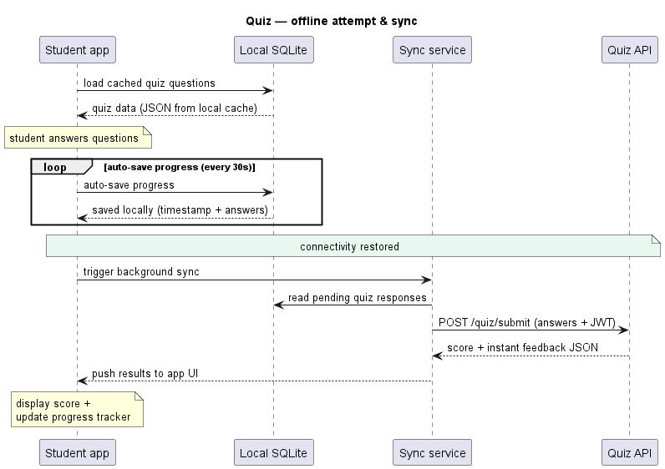
  - 5. Lecture Upload and Transcoding Flow
This scenario highlights the instructor’s role in content creation.
- The Instructor App uploads lecture files in resumable chunks to the App Server.
- The FFmpeg Transcoder converts raw files into low/standard/high + audio formats.
- Files are stored as .m3u8 and .ts segments for streaming.
- The Notification Service informs the instructor that the lecture is live.
This flow ensures that content is optimized for adaptive delivery.
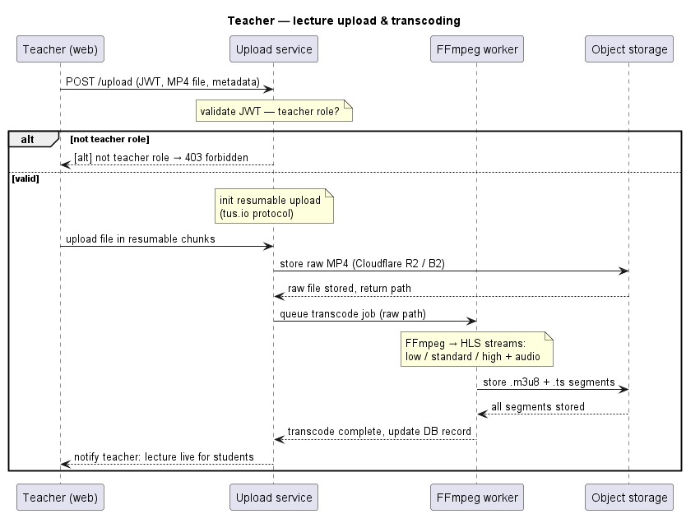
  - 6. Quiz Creation and Publishing Flow
This scenario shows how instructors prepare assessments.
- The Instructor creates quizzes through the Quiz API.
- Quiz IDs are stored in the Database.
- Questions (MCQ, T/F, short-answer) are validated and saved.
- The quiz JSON is pushed to enrolled student devices for offline caching.
This flow ensures that quizzes are validated, stored, and distributed seamlessly.
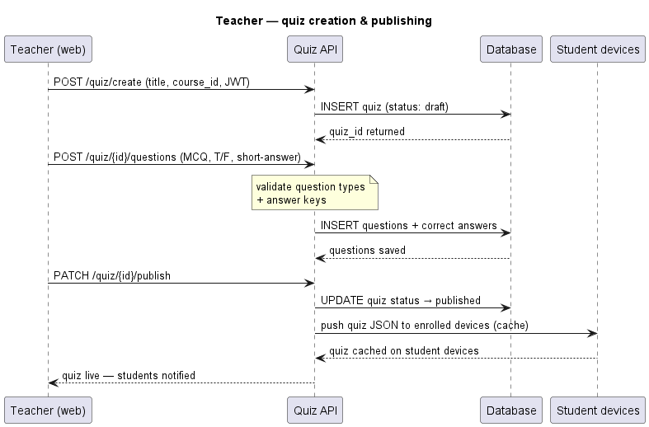
  - 7. Teacher Dashboard Flow (Student Engagement Monitoring)
This scenario empowers instructors to monitor student progress.
- The Dashboard API verifies course ownership.
- It requests metrics from the Analytics Service, which queries the Database.
- Metrics such as average score and completion rate are computed.
- Students with <30% completion are highlighted.
- The instructor can send manual push/SMS reminders directly from the dashboard.
This flow ensures data-driven teaching and personalized intervention.
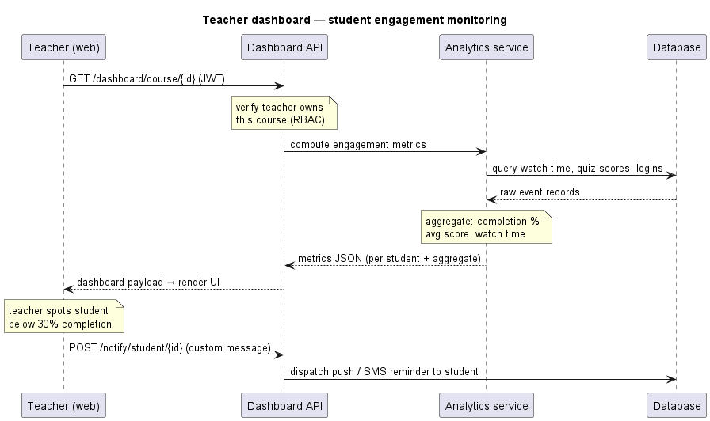

  - 8. Live Class and Participant Feed Flow
This scenario captures synchronous learning.
- The Instructor App makes a POST request to the Session API.
- The Session API pushes reminders to students.
- The WebRTC Agora Object enables students to join multiple channels simultaneously.
- The instructor can share screen and whiteboard.
- Attendance logging and session recording are captured at the end.
This flow ensures real-time collaboration and accountability.
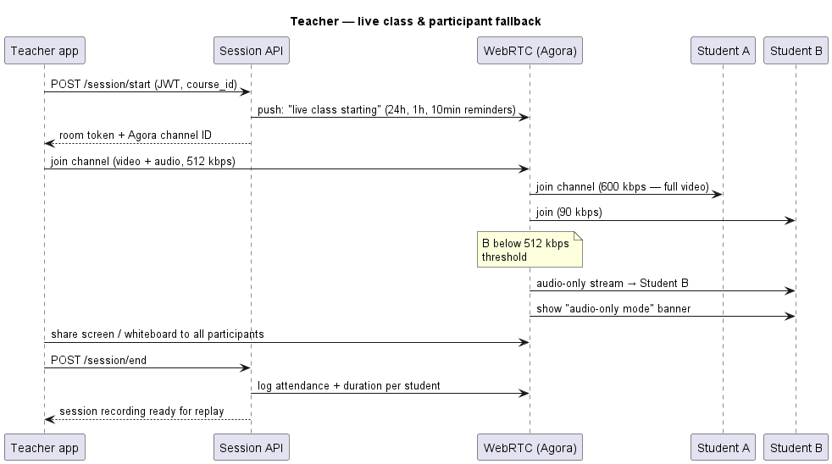
The Sequence Diagrams show the temporal choreography of the Adaptive E-Learning Platform. They prove that the system is not static — it adapts, synchronizes, and responds in real time to user actions and network conditions. From login to live class, every scenario is modeled to ensure resilience, personalization, and engagement.

VI. Class Diagram

While dynamic diagrams capture the fluid behavioral timelines of a platform, the static Class Diagram establishes its permanent backbone. This report details the structural blueprints for the Adaptive E-Learning Platform, providing a comprehensive design rationale for every entity, boundary condition, and object relationship.
Rather than building an abstract, generic layout, this architecture is directly engineered to resolve real-world user data collected from our 99 field survey respondents. It balances a clear split in user priorities namely, the 50% demand for live video streams and the 45% demand for resource saving features by embedding adaptive logic natively within the system's structural types. 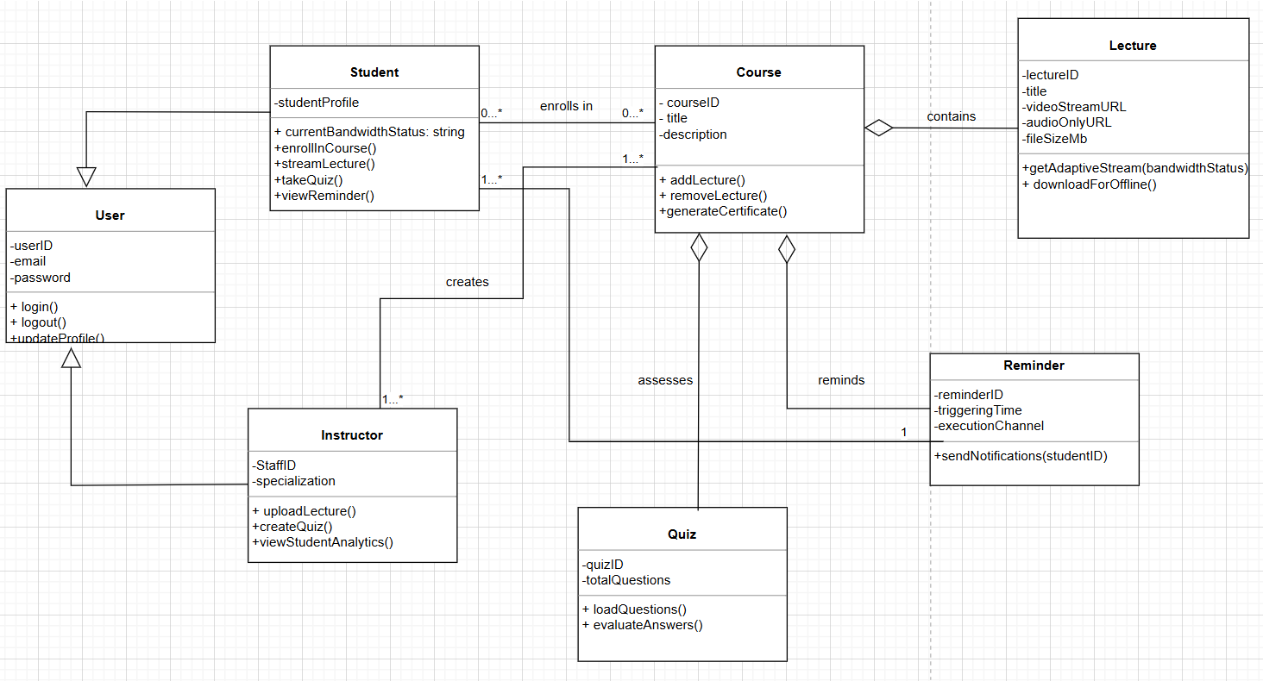

2. Unified Modeling Language (UML) Structural Notation
To preserve technical clarity for implementation teams, the diagram enforces standard UML three compartment block layouts. This notation explicitly defines data encapsulation and system accessibility guidelines:
- The Identifier Block (Top): Clear semantic labeling of the class type domain.
- The State Field (Middle): Private data states are explicitly protected using a minus prefix ( ₋ ), preventing unvalidated corruption from external objects. Public states are declared using a plus prefix ( ₊ ).
- The Behavioral Field (Bottom): Exposed functions and executable operations, defining explicit parameter constraints and type returns.

3. Domain Specialization and Class Responsibilities
The blueprint distributes platform mechanisms across three isolated operational blocks, reducing structural dependencies and ensuring long-term code maintainability.

3.1 Identity Management Domain
This tier coordinates authentication boundaries and directly answers user privacy concerns highlighted during field data collection.
- User Class (Abstract Base): Gathers generalized criteria shared by all human entities. It
- secures identity states through private fields ( - userID , - email , and - passwordHash ) while exposing global gateways ( + login() , + logout() ).
- Student Class: Represents the primary learner domain. It integrates the vital tracking attribute + currentBandwidthStatus: String , which serves as a live connection-tier flag (Low, Medium, High) to feed downstream delivery engines.
- Instructor Class: Captures creator controls. It houses authorization methods like ₊uploadLecture() , + createQuiz() , and + viewStudentAnalytics() .

3.2 Asynchronous Content and Adaptive Streaming Domain
This block directly manages educational resources, providing the mechanical components to handle local infrastructure constraints.
- Course Class: The central domain container, holding course identifiers, contextual descriptions, and orchestration routines like + addLecture() and + generateCertificate().
- Lecture Class: Handles structural asset delivery. To mitigate high internet costs, it separates content access routes into distinct properties: - videoStreamURL and - audioOnlyURL.
The key behavioral method, + getAdaptiveStream(bandwidthStatus), intercepts incoming student requests. If a student's profile indicates degraded data performance, the method routes the lightweight audio-only URL instead, capping data usage under 20MB per hour.

3.3 Evaluation and Communication Domain
- Quiz Class: Satisfies the 40% target user demand for testing frameworks. It handles question pools and score checks via ₊
evaluateAnswers().
- Reminder Class: Satisfies the 35% user request for automated tracking reminders, executing notifications through independent channels

4. Structural Relationships and Design Rationale
The connections within this class model determine how the system behaves at runtime. Two relationships; Generalization and Aggregation form the core design choices of this architecture.

4.1 Generalization (The Common Identity Rule)
This implements a strict Is-A structural rule. It mandates that a Student is a user, and an Instructor is a user.

4.2 Aggregation over Composition (The Content Lifecycle Rule)
The links between the Course container and its internal components (Lecture and Quiz) are modeled using Aggregation rather than Composition. This is a critical architectural choice for data reusability:
Why Aggregation is Required for Content Management:
Composition establishes a tight, fatal lifecycle dependency: if a parent object is destroyed, all its parts are permanently erased from system memory. Aggregation, conversely, separates these lifecycles. If the university drops a specific course, the course container is deleted, but the underlying media assets (heavy video files and audio guides) survive independently within the system repositories. This allows instructors to re-link these assets to alternative modules or archive them without risking data loss or forcing costly duplicate uploads.

4.3 Association and Multiplicity Matrix
Multiplicities define the precise quantitative rules governing runtime data instances:
Connection Path | UML  Structural  Type | Multiplicity  Bound | System Operational Meaning
Student ↔ Course | Directed  Association | 0..* to 0..* | A many-to-many relationship. A learner can enroll in multiple modules; a course can support unbounded student enrollment records.
Instructor →  Course | Directed  Association | 1..* to 0..* | A course requires ownership by at least one or more instructors; an educator can manage zero or multiple modules.
Course ◊ Lecture | Aggregation  Link | 1 to 1..* | A course acts as a parent shell requiring one or more sequential lecture instances before it can be deployed to users.
Course ◊ Quiz | Aggregation  Link | 1 to 1..* | A course manages student evaluation by embedding one or more distinct quiz modules.
Reminder →  Student | Association  Link | 1 to * | A centralized runtime alert instance queries, formats, and broadcasts messaging events to multiple student endpoints.

4.4 Separation of Quiz/Reminder from the Student Class
A frequent design trap is associating the Quiz and Reminder classes directly to the Student class because students are the ones interacting with them. This architecture rejects that model to prevent massive database duplication:
- The Quiz Rationale: A quiz belongs structurally to the Course curriculum. It is a shared educational asset. A student merely interacts with it temporarily to log a score. If a quiz were aggregated to a student, removing a student record would delete the test itself from the platform.
- The Reminder Rationale: Reminders are triggered by course timeline milestones (such as live class alerts). Linking them to individual student profiles would force the server to instantiate 99 separate copies of the exact same notification rule for 99 students in a class. Aggregating reminders to the Course allows the system to store exactly one rule and broadcast it seamlessly, preserving server memory and ensuring database efficiency.

VII. Deployment Diagram
The Deployment Diagram is the architectural map of the Adaptive E-Learning Platform. While the DFDs and sequence diagrams show how data flows and how events unfold, the deployment diagram shows where components live physically and how they communicate across tiers. It is the bridge between software design and infrastructure engineering, ensuring that the platform is scalable, secure, and resilient in low-resource environments.
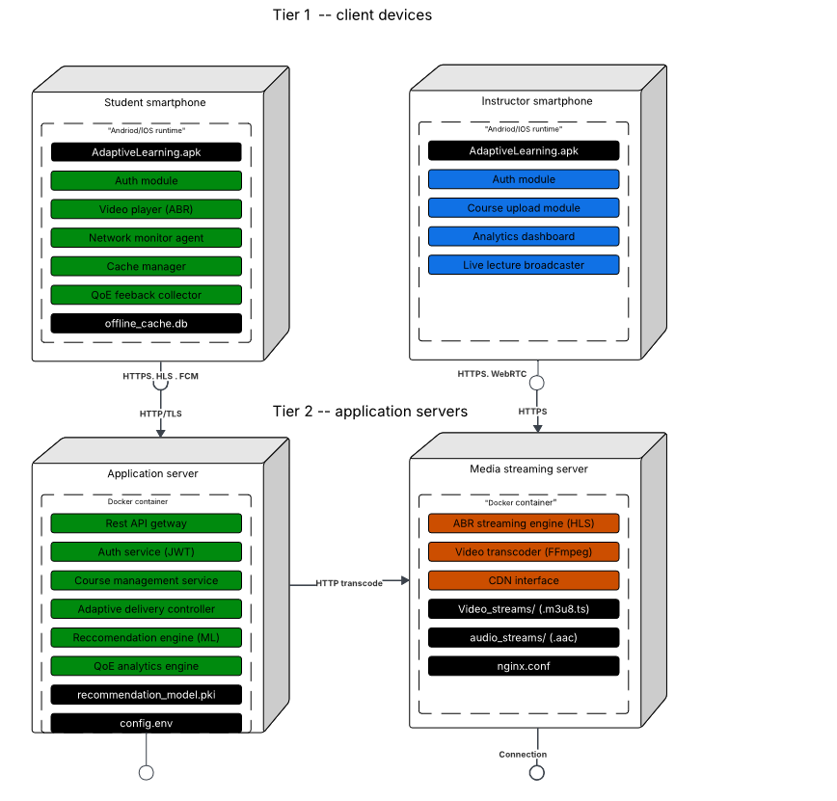
  - 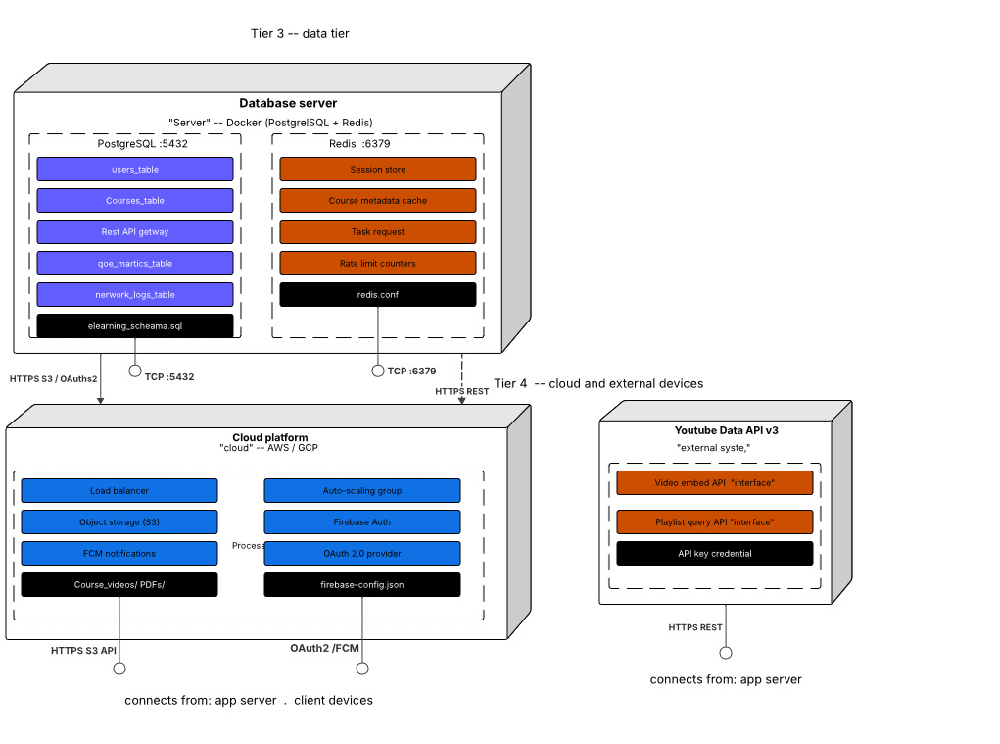
  - 1. Tier 1 — Client Devices
This tier represents the end-user environment: smartphones and tablets used by students and instructors.
- Nodes: Student smartphone, Instructor smartphone.
- Runtime: Android/iOS runtime environments.
- Components:
  - AdaptiveLearning.apk: The mobile application that hosts all student/instructor interactions.
  - Auth Module: Handles login and token storage.
  - Video Player (ABR): Plays adaptive bitrate streams, switching between HD, SD, or audio-only.
  - Course Upload Module: Enables instructors to upload lectures.
  - Network Monitor Agent: Continuously measures bandwidth and latency.
  - Analytics Dashboard: Displays student progress and instructor insights.
  - Cache Manager & offline_cache.db: Stores downloaded lectures and quizzes for offline use.
  - Live Lecture Broadcaster: Enables real-time class sessions via WebRTC.
  - QoE Feedback Collector: Captures satisfaction ratings and playback quality metrics.
Protocols: HTTPS for secure communication, HLS for adaptive streaming, WebRTC for live sessions, FCM for push notifications.
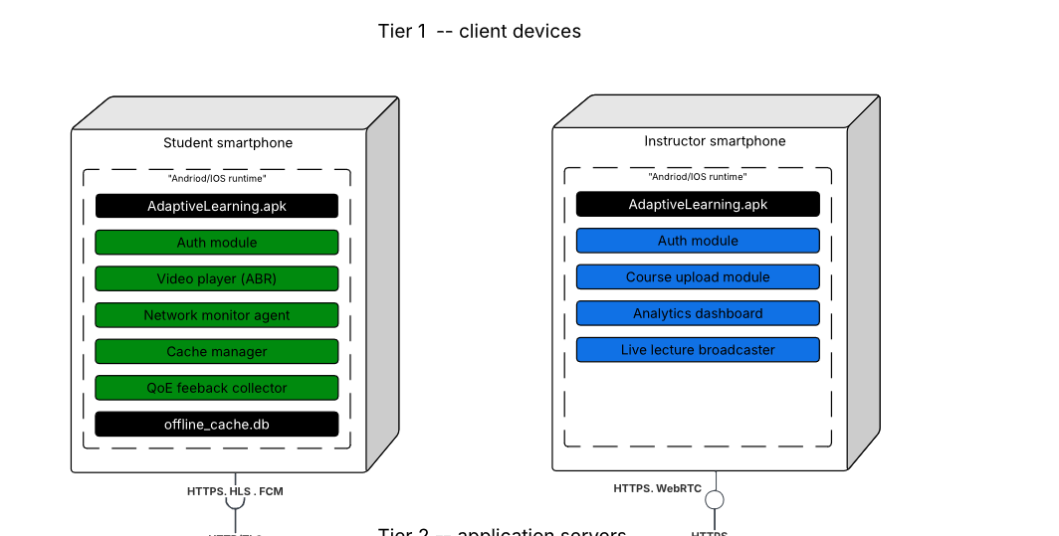
  - 2. Tier 2 — Application Servers
This tier is the processing core of the system, hosted in Docker containers for scalability.
- Nodes: Application server, Media streaming server.
- Components:
  - REST API Gateway: Entry point for all client requests.
  - Auth Service (JWT): Issues and validates tokens.
  - Course Management Service: Handles uploads, metadata, and course organization.
  - ABR Streaming Engine (HLS): Serves adaptive streams.
  - Video Transcoder (FFmpeg): Converts raw uploads into multiple formats (HD, SD, audio).
  - Adaptive Delivery Controller: Decides which stream to serve based on QoS.
  - Recommendation Engine (ML): Suggests personalized content.
  - QoE Analytics Engine: Processes feedback and logs.
  - CDN Interface: Connects to external content delivery networks.
  - nginx.conf & config.env: Configuration files for server management.
Artifacts: Video streams (.m3u8, .ts), audio streams (.aac), recommendation models (.pki).
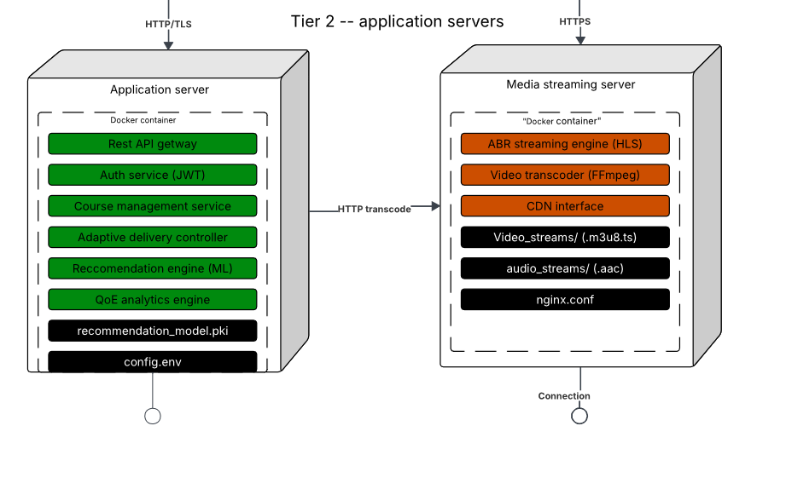
  - 3. Tier 3 — Data Tier
This tier is the storage backbone of the platform.
- Nodes: Database server running Docker containers for PostgreSQL and Redis.
- Components:
  - PostgreSQL (Port 5432): Stores persistent data -- users_table, courses_table, qoe_metrics_table, network_logs_table.
  - Redis (Port 6379): Provides fast caching — session store, course metadata cache, rate limit counters.
  - Schemas & Configs: elearning_schema.sql, redis.conf.
Protocols: TCP for DB connections, HTTPS for secure API calls to S3 and OAuth2 providers.
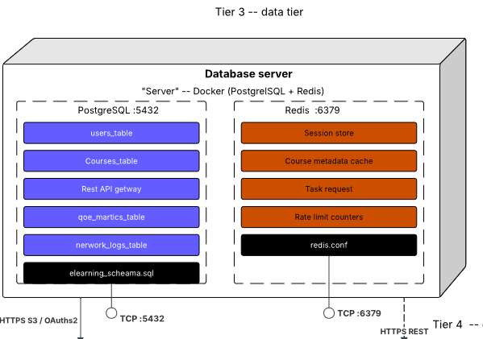
  - 4. Tier 4 — Cloud and External Services
This tier ensures scalability, resilience, and integration with external APIs.
- Cloud Platform (AWS/GCP): Provides infrastructure services.
- Components:
  - Load Balancer: Distributes traffic across servers.
  - Auto-Scaling Group: Dynamically adjusts server capacity.
  - Object Storage (S3): Stores course videos and PDFs.
  - Firebase Auth & FCM Notifications: Handles authentication and push messaging.
  - OAuth 2.0 Provider: Ensures secure identity management.
  - YouTube Data API v3: Enables video embedding and playlist queries.
Protocols: HTTPS S3 API, OAuth2, FCM, REST APIs.
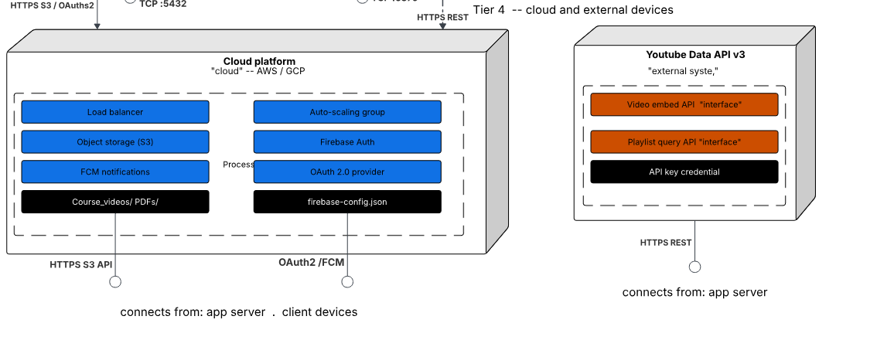
  - 5. Why the Deployment Diagram Matters
- It shows where software lives physically — on devices, servers, databases, and cloud.
- It ensures scalability through Docker containers, load balancers, and auto-scaling groups.
- It guarantees resilience with offline caching, resumable uploads, and CDN integration.
- It enforces security with HTTPS/TLS, JWT tokens, and OAuth2.
- It connects directly to other diagrams:
  - Student’s offline_cache.db ↔ DFD offline content manager.
  - Instructor’s uploadLecture() ↔ FFmpeg transcoder.
  - QoE feedback ↔ QoE analytics engine.
  - Notifications ↔ FCM service.

The Deployment Diagram is the physical architecture blueprint of the Adaptive E-Learning Platform. It shows how client devices, application servers, databases, and cloud services work together to deliver secure, adaptive, and scalable learning. By layering the system into four tiers, the diagram ensures that every component — from offline caching on smartphones to ML-based recommendations in the cloud — is accounted for and connected.

VIII. Conclusion and References
The Adaptive E-Learning Platform has been modeled through six complementary diagrams — each one offering a unique lens into the system’s architecture and behavior. Together, they form a cohesive, layered narrative that transforms abstract requirements into a tangible, implementable design.

1. Context Diagram (DFD Level 0)
At the highest level, the platform is shown as a single process interacting with Students, Instructors, Administrators, Network/CDN, and Authentication Services. This diagram defines the system boundary, clarifies external interactions, and ensures stakeholders understand the big picture before diving into internal processes. It is the entry point into system modelling.

2. Data Flow Diagrams (Levels 1–3)
The DFD hierarchy expands the context into main processes, data stores, and sub-processes.
- Level 1: Authentication, Course Content Management, Network Monitoring, Adaptive Delivery, Video Streaming, QoE Assessment, Recommendation Engine.
- Level 2: Shows how each process interacts with data stores (User DB, Course DB, Network Logs, QoE Metrics, Recommendation Models, Media Cache).
- Level 3: Decomposes Adaptive Delivery into Quality Banding, QoS Classifier, Bitrate Negotiator, Offline Content Manager, Buffering Optimizer.
This layered approach ensures clarity, scalability, and adaptability.

3. Use Case Diagram
The Use Case Diagram humanizes the system by showing functional requirements from the user’s perspective.
- Students: Enroll, access/download materials, track progress, take quizzes, check scores, submit feedback.
- Instructors: Upload content, manage classes, assign quizzes, monitor dashboards.
- Administrators: Manage accounts.
- Developers: Test and update software.
Relationships (include, extend) clarify mandatory vs. optional interactions. This diagram ensures the platform is learner-centered, teacher-supported, admin-governed, and developer-maintained.

4. Sequence Diagrams
The Sequence Diagrams capture the temporal choreography of the system:
- Login authentication flow.
- Offline content download.
- Adaptive streaming under bandwidth changes.
- Offline quiz attempt and sync.
- Lecture upload and transcoding.
- Quiz creation and publishing.
- Teacher dashboard monitoring.
- Live class and participant feed.
These flows prove that the system is dynamic, resilient, and responsive to both user actions and network conditions.

5. Class Diagram
The Class Diagram defines the static skeleton of the platform.
- Identity Management Domain: User (abstract), Student, Instructor.
- Content & Adaptive Streaming Domain: Course, Lecture.
- Evaluation & Communication Domain: Quiz, Reminder.
Relationships (generalization, aggregation, association) enforce privacy, reusability, scalability, and efficiency. By embedding adaptive logic directly into structural types, the class diagram ensures the system is engineered for low-resource settings.

6. Deployment Diagram
The Deployment Diagram maps software components to physical nodes across four tiers:
- Tier 1: Client devices (smartphones, offline cache, ABR player, QoE feedback collector).
- Tier 2: Application servers (REST API, Auth, Course Management, FFmpeg, Adaptive Delivery, Recommendation Engine, QoE Analytics).
- Tier 3: Data tier (PostgreSQL, Redis, session store, metadata cache, QoE metrics, network logs).
- Tier 4: Cloud and external services (AWS/GCP, Load Balancer, Auto-Scaling, S3, Firebase Auth, FCM, OAuth2, YouTube API).
This diagram ensures the platform is scalable, secure, and resilient, capable of handling real-world challenges in low-bandwidth environments.

Final Reflection
By weaving together Context, DFDs, Use Case, Sequence, Class, and Deployment diagrams, this report demonstrates a complete system design. Each diagram is not isolated but interconnected:
- The Context Diagram sets boundaries.
- The DFDs show flows and decomposition.
- The Use Case Diagram captures user needs.
- The Sequence Diagrams show dynamic interactions.
- The Class Diagram defines static structure.
- The Deployment Diagram maps physical architecture.
Together, they form a holistic blueprint for an Adaptive E-Learning Platform that is secure, scalable, adaptive, and learner-centered.

References
- Pressman, R. S. (2014). Software Engineering: A Practitioner’s Approach. McGraw-Hill.
- Sommerville, I. (2015). Software Engineering. Pearson.
- Booch, G., Rumbaugh, J., & Jacobson, I. (2005). The Unified Modeling Language User Guide. Addison-Wesley.
- Fowler, M. (2004). UML Distilled: A Brief Guide to the Standard Object Modeling Language. Addison-Wesley.

